Cartridge type HRC fuse dimensions.

--------------------------------------------------------------------------------------------------------------------------------------

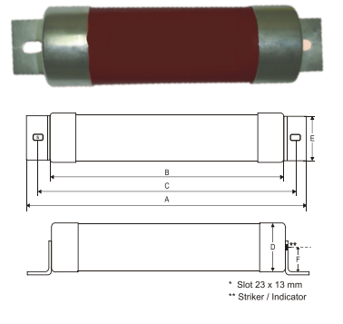

|  |  |  |  |  |  |
| --- | --- | --- | --- | --- | --- |
| A | B | C | D | E | F |
| 360mm | 254mm | 310mm | 85mm | 63mm | 43.5mm |